# **Department of Computer Science and Engineering Islamic University of Technology (IUT)** A subsidiary organ of OIC

# 

# **Laboratory Report**

# CSE 4412 : Data Communication and Networking Lab

## 

## **Name: Md Muktadir Mazumder Student ID: 190042136 Section: Lab Group B Semester: 4th Semester Academic Year: 2020-21**

**Date of Submission: 08-12-2021**

### **Title:** Creating a Simple LAN (Local Area Network) in CISCO Packet Tracer.

### **Objective**:

1. Create a Simple LAN (Ring Topology) by connecting multiple end devices
2. Significance of IP address
3. Difference between Switch and Hub.

### **Devices/ software Used**:

1. Device : Personal Computer
2. Software : Cisco Packet Tracer

### **Diagram of the experiment:**

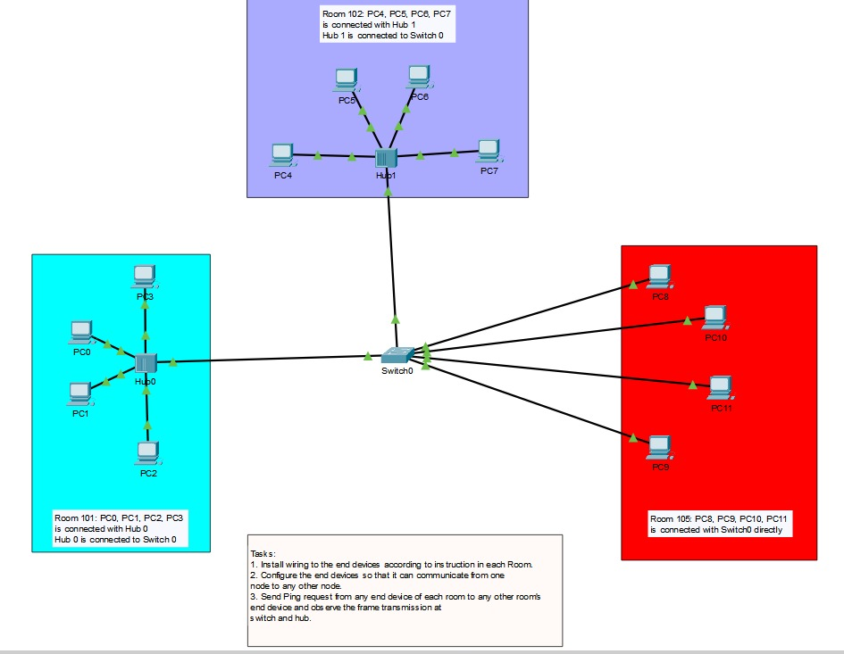

### **Working Procedure:**

1. Connected all the devices with “Copper Straight Through” cable since they all belong to different layers.
2. All the links are created using the “Fast Ethernet Port”.
3. After that clicking on a device, the following steps were performed:
4. Opened the Desktop tab.
5. Visiting the IP-Configuration option, the IP Address of all the PCs were typed and Subnet mask was created automatically.

1. The first three parts of the IP Address were the same; example

192.168.5.(different for all the connected PCs).

5) By clicking on PC1 of Room 101;the following steps were performed:

I) Opened the Desktop tab.

II) Choosing the Command Prompt. The following commands were typed--

A) Ping 192.168.5.12(IP Address of PC5 in Room102)

B) Ping 192.168.5.13(IP Address of PC11 in Room 105)

### **Observation**:

1. One of the differences between Switch and Hubs observed during the simulation is that Switch has more ports than Hub.
2. If there is an end device that has a different IP address for the first three parts, then Ping request says ‘timed out’ which means the device couldn’t communicate with that end device.
3. **Explanation of Communication scenario between Room 101 and Room 102 :**

1. At first PC1 sent packet to Hub0, then Hub0 sent the packet to all the nodes connected to it.

2. Switch0 sent the packet to Hub1 only after receiving the packet from PC1 as the destination IP Address is connected to the Hub1.

3. Then Hub1 sent this packet to all the nodes which are connected to it. PC5 received the packet and all other nodes rejected it because the destination IP Address is not same as their IP Address.

4.After that PC5 returned the packet to Hub1 in response travelling through Switch0. 5. PC1 received the packet in response through Hub0.

**Explanation of Communication scenario between Room 101 and Room 105 :**

1. At first PC1 sent packet to Hub0, then Hub0 sent the packet to all the nodes connected to it.
2. Switch0 sent the packet to PC11.
3. In response PC8, sends the packet to PC1 through Hub0 travelling through Switch0.
4. Lastly, Hub0 send these packet to all the nodes in Room101 but in response only PC1 accepted the packet and all other nodes rejected it.

By observing the above two scenarios, it can be said that Switches are much efficient than Hubs.Switch only sends data to the device which is requested but Hub sends data to all connected devices.

### **Challenges:**

### Powering on Hub1 was hidden in my Cisco Packet Tracer’s preferences.for which connection of Hub1 with Switch0 and connected PCs PC4,PC5,PC6,PC7 was impossible. So had to enable Buffer Filtered Events Only by visiting Miscellaneous tab from Preferences option.

### 